**Number Guess Game**

**Service:**

Implement the NumberGuess service as a RESTful service. Host the service on localhost of .Net Development server or IIS Express server.

**Client 1:**

Create an ASP .Net Web Application or MVC 4 Web Application (in .Net Framework 4) to consume the RESTful service

**Client 2:**

Develop Silverlight Application with animation to consume the RESTful service.

**Tool/IDE**

**Visual Studio version: 2013**

**Solution 1: NumberGuessGame**

This RESTful project. In this solution, there are two projects:

1. NumberGuessGame: This is Rest Service and I have used **WCF Service Application** template.
2. NumberGuessRESTApplication: This is client and I have used .Net Web Application template.

**How to run:** To run this solution, open solution in Visual Studio and make project NumberGuessRESTApplication as a Start Up project and **run the solution as Start with Debugging**.

**Snapshots:**

Step 1:

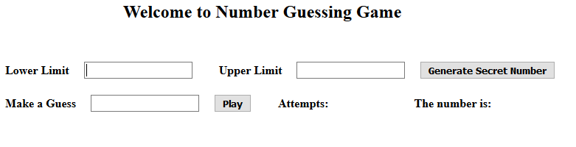

Step 2: Input lower limit and upper limit and click on Generate Secret Number

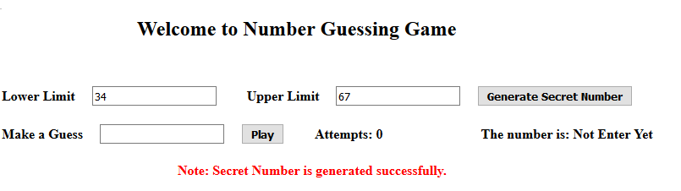

Step 3: Make a guess. If the guess is smaller than secret number then it show “Too small” and if it is bigger the shows “Too big” and if it is equal to secret number then shows “Correct”.

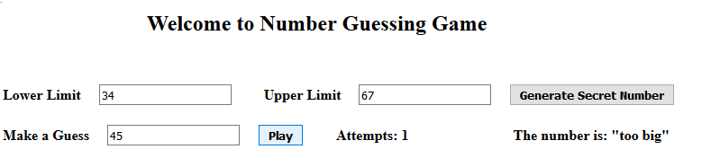

Step 4:

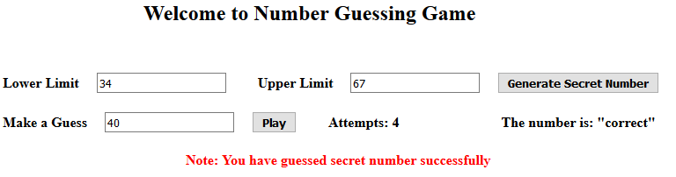

**Solution 2: NumberGuess_Silverlight**

In this solution, there are two projects:

1. NumberGuess_REST: This is Rest Service and I have used **WCF Service Application** template.
2. SilverlightApplication1 and SilverlightApplication1.Web: are together made client.

**How to run:** To run this solution, open solution in Visual Studio and make project SilverlightApplication1.Web as a Start Up project and **run the solution as Start without Debugging**. If there is any problem showing any exception then **run the solution as Start Debugging.** And open the project in Internet Explorer and Silverlight is more compatible with it than Chrome or Firefox

**Snapshots:**

Step 1: The Silverlight application consuming RESTful service.

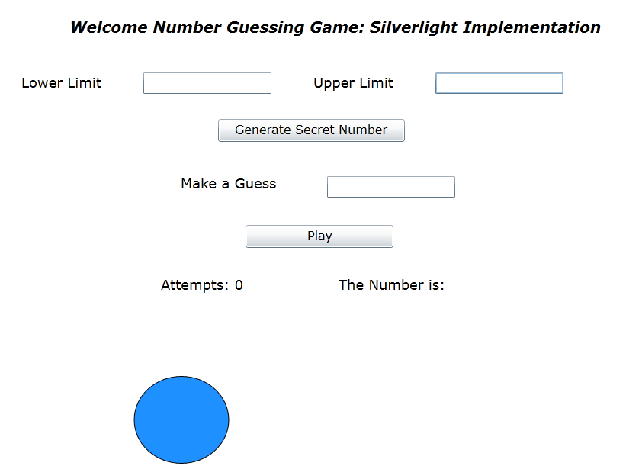

Step 2: Input lower limit and upper limit and click on Generate Secret Number

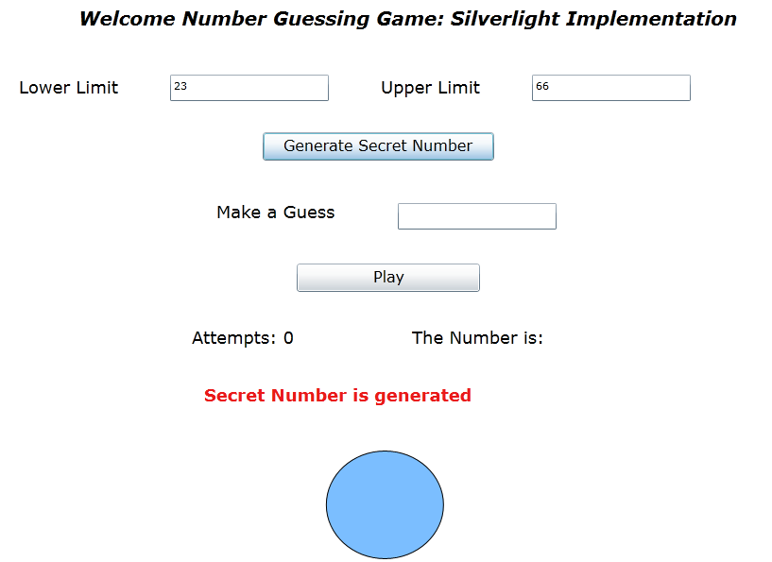

Step 3: Make a guess: if the guess is Too small or Too big, color of eclipse changes to Pink and if it is correct then changes to Green.

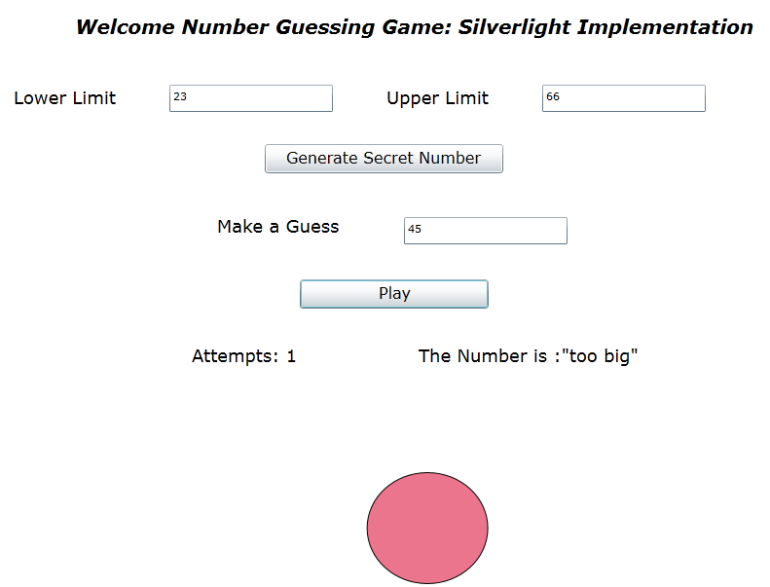

Step 4: Correct one

